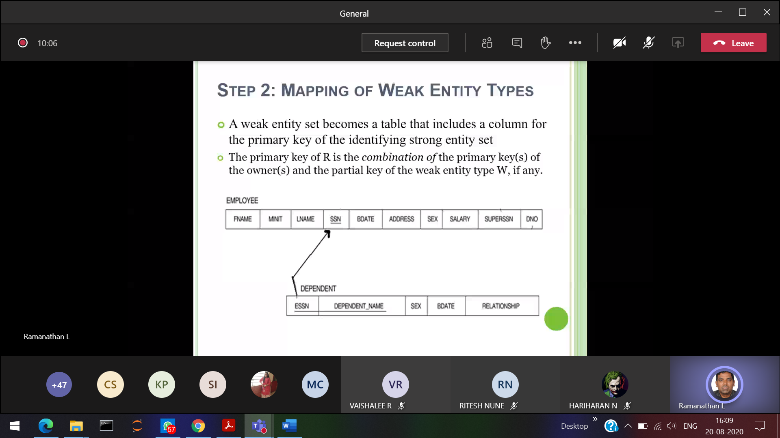

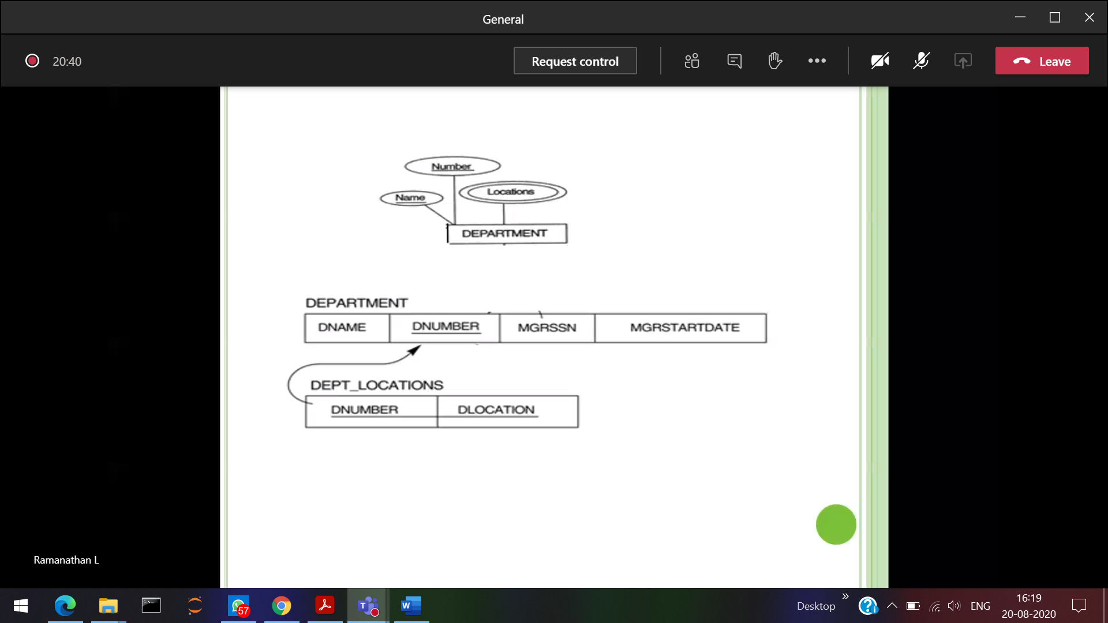



Location 🡪 multi-valued attribute

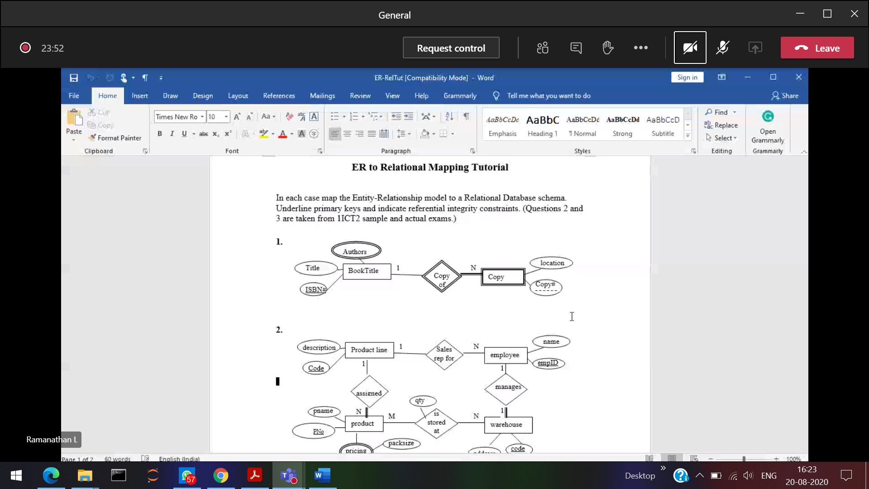

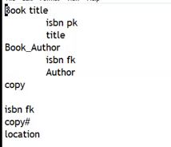

1:N relation ship

ISBN 🡪primary key (Book title)

🡪Foreign key (Copy)

Book author table [ Multivalued ]  
ISBN(foreign key) Author

**Represent in this format**

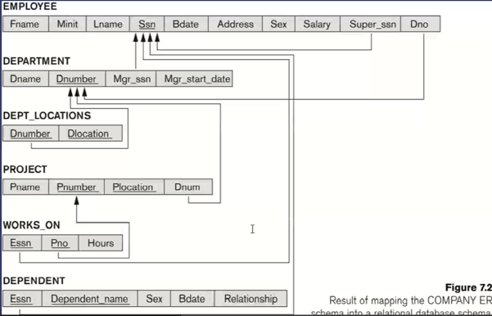

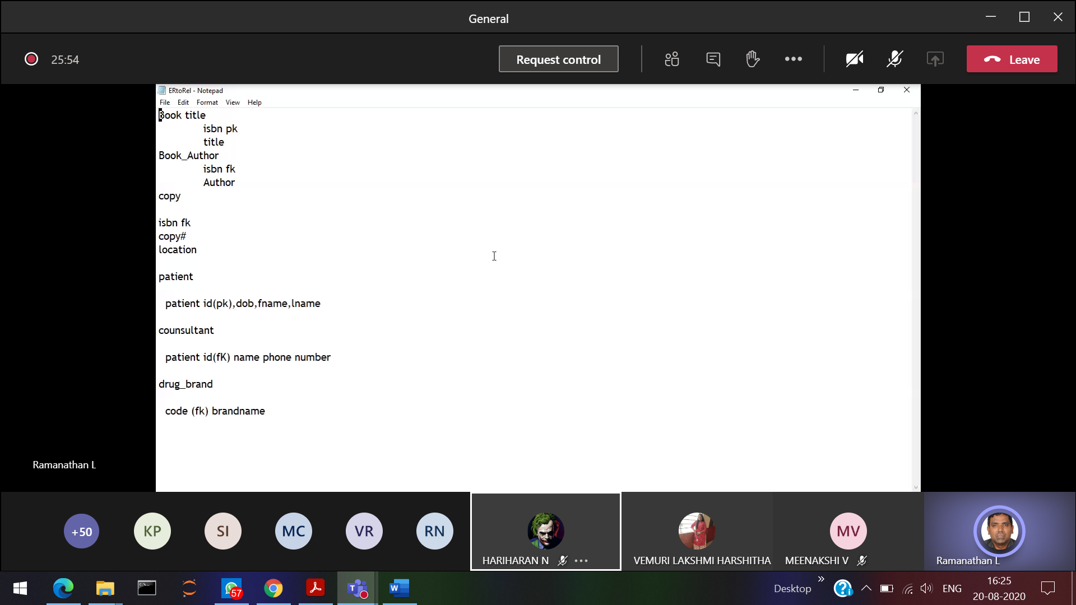

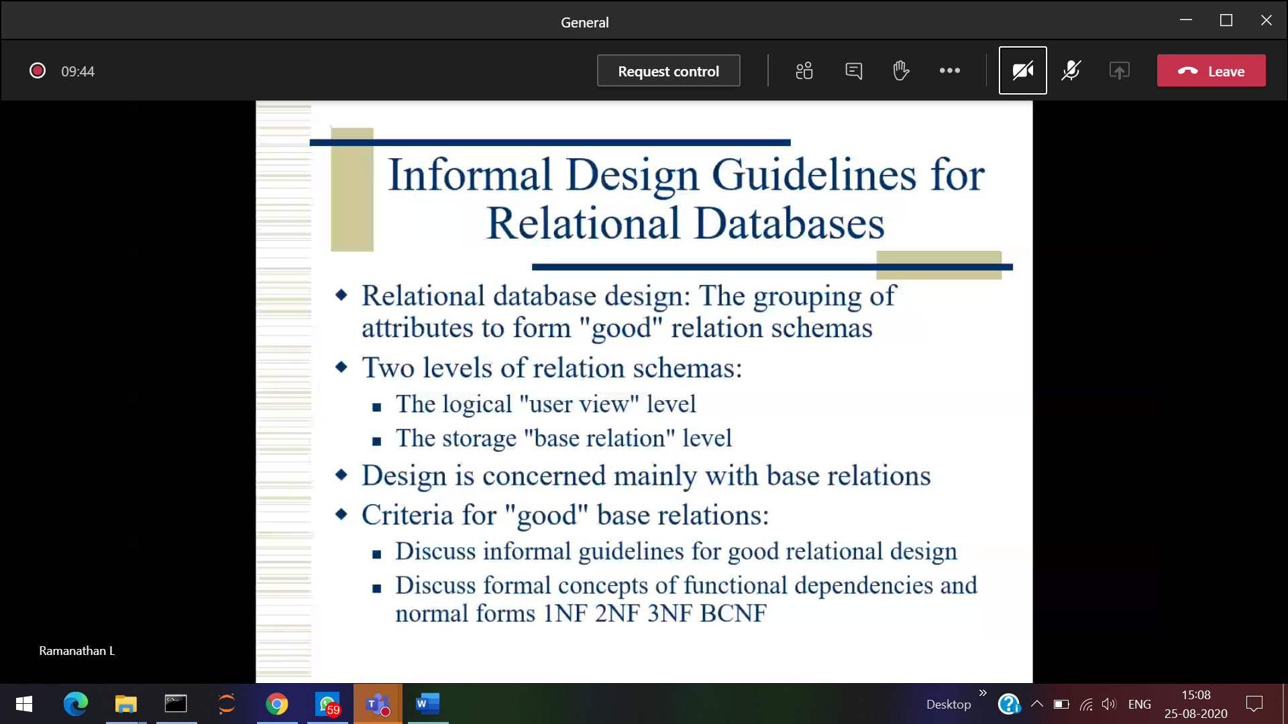

To design normalization

Eg: register number grade history



Registered subjects

If I enter register number, I will come to know all the details of that particular student. So all the attributes depending upon register number. 🡪 Functional Dependency

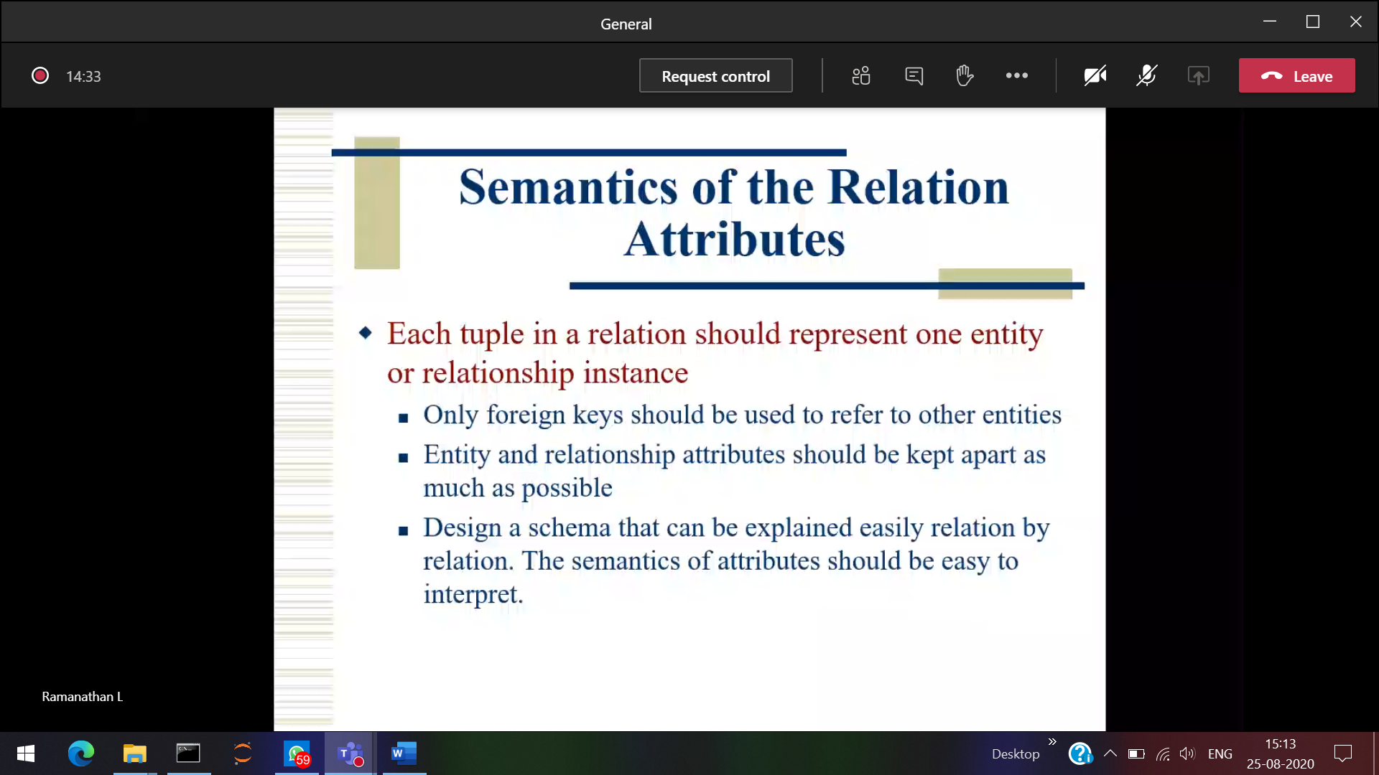

Tuple 🡪record .

Student table 🡪 relating student info  
faculty table 🡪 relating faculty info

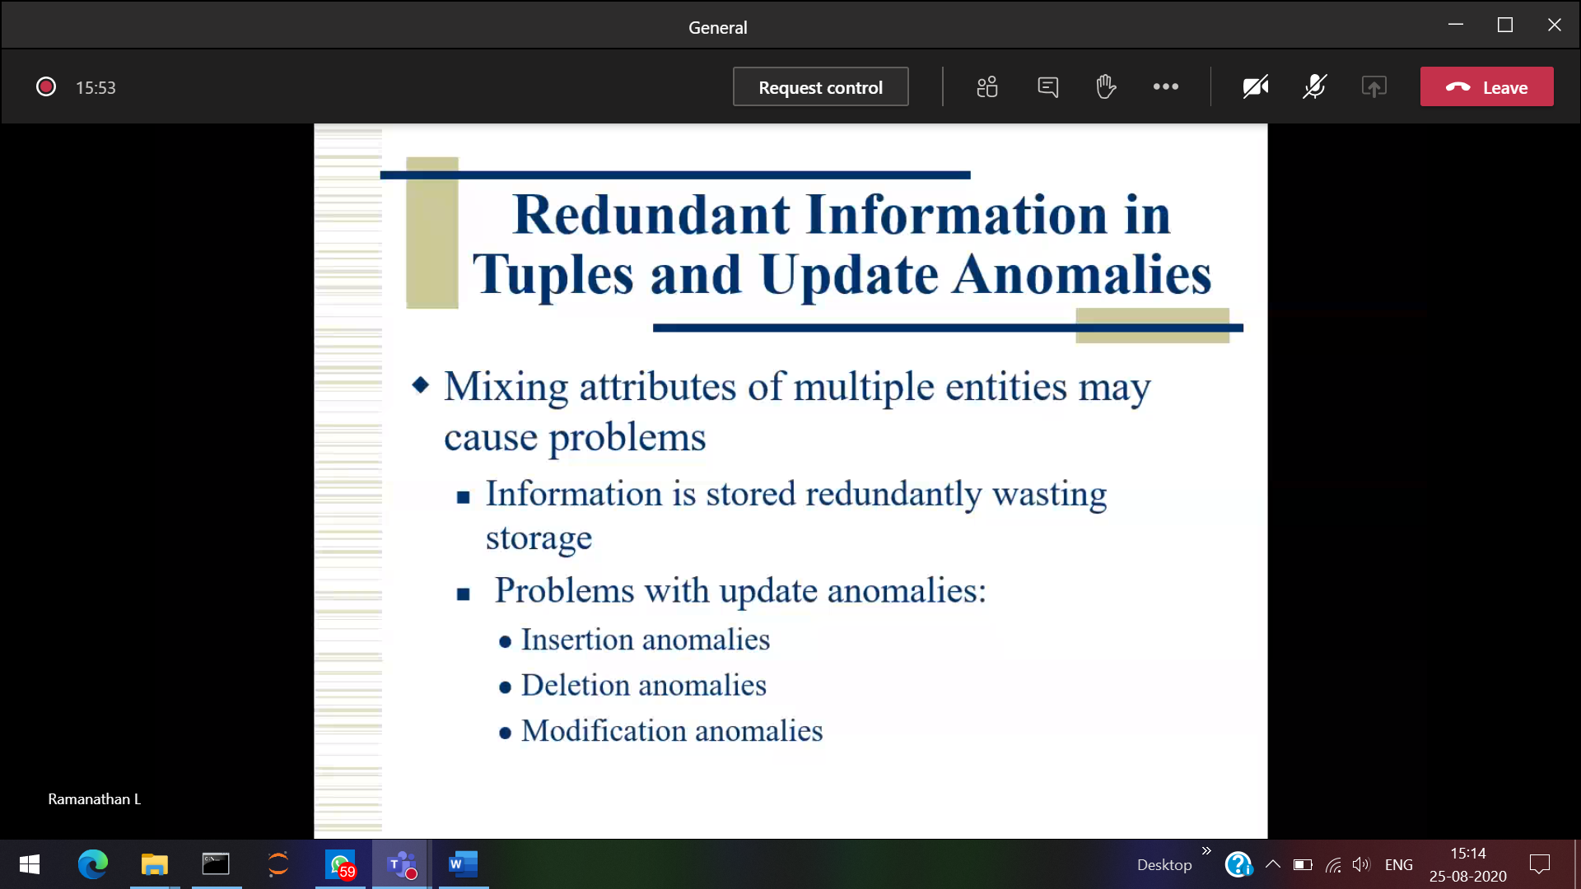

didn’t created employee table. But we are trying to insert emp name.

Inserting and update Anomalies

1 Project number missing in the database, but we are trying to remove that value 🡪 Deletion anomalies

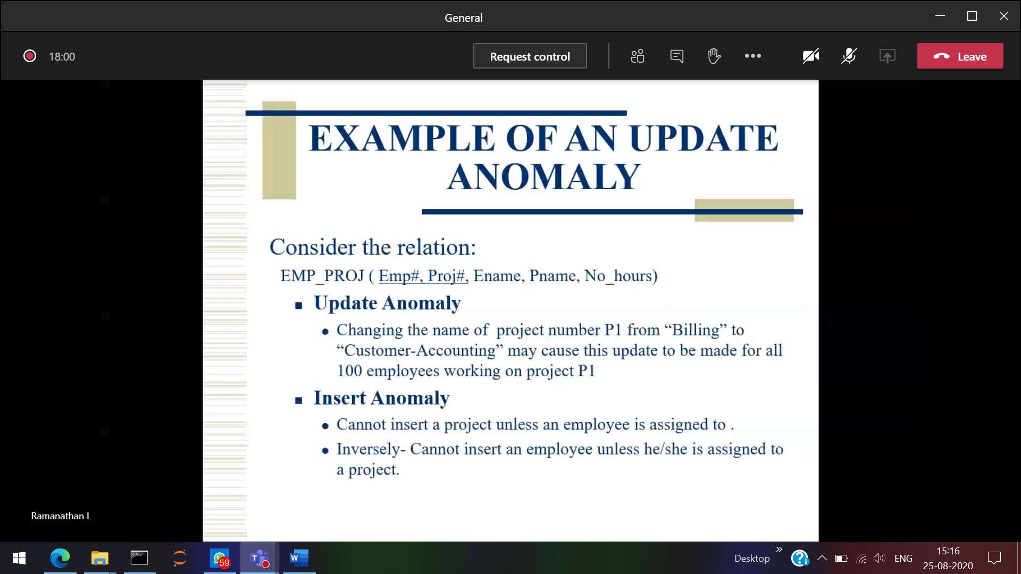

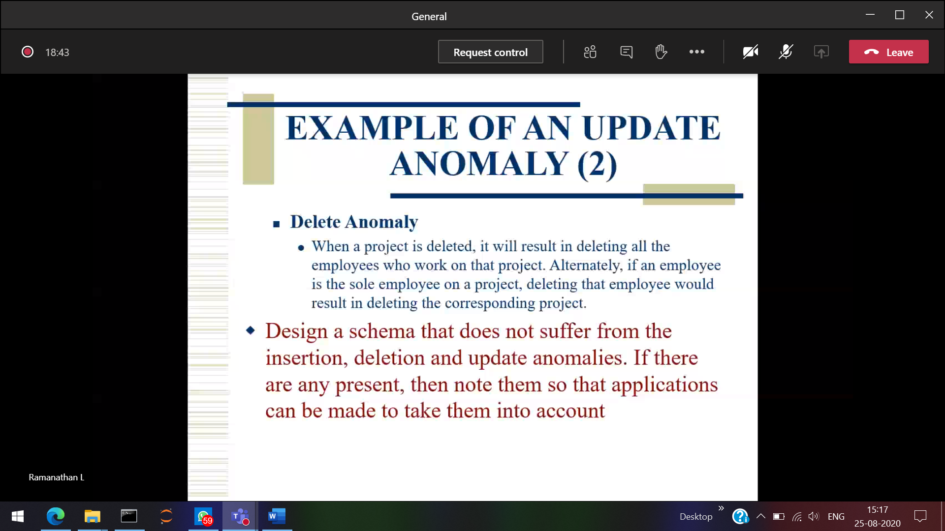

On delete set null  
On delete cascade

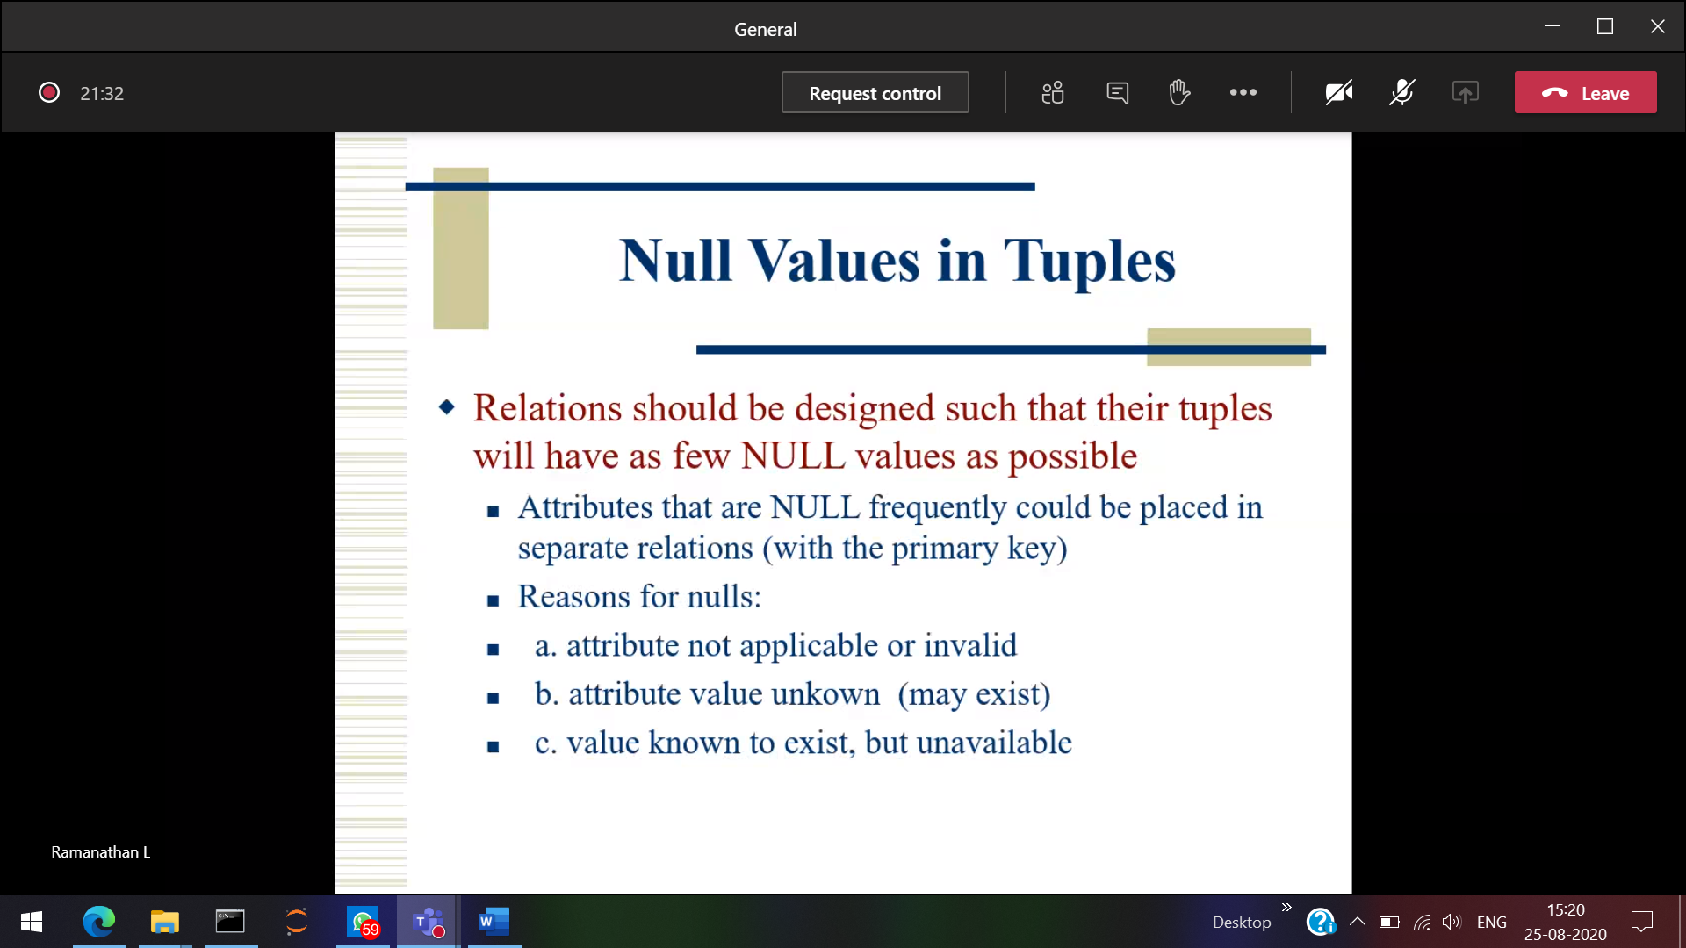

**In worst case there are no other option 🡪 Use NULL**

**Don’t use too much , use whenever required.**

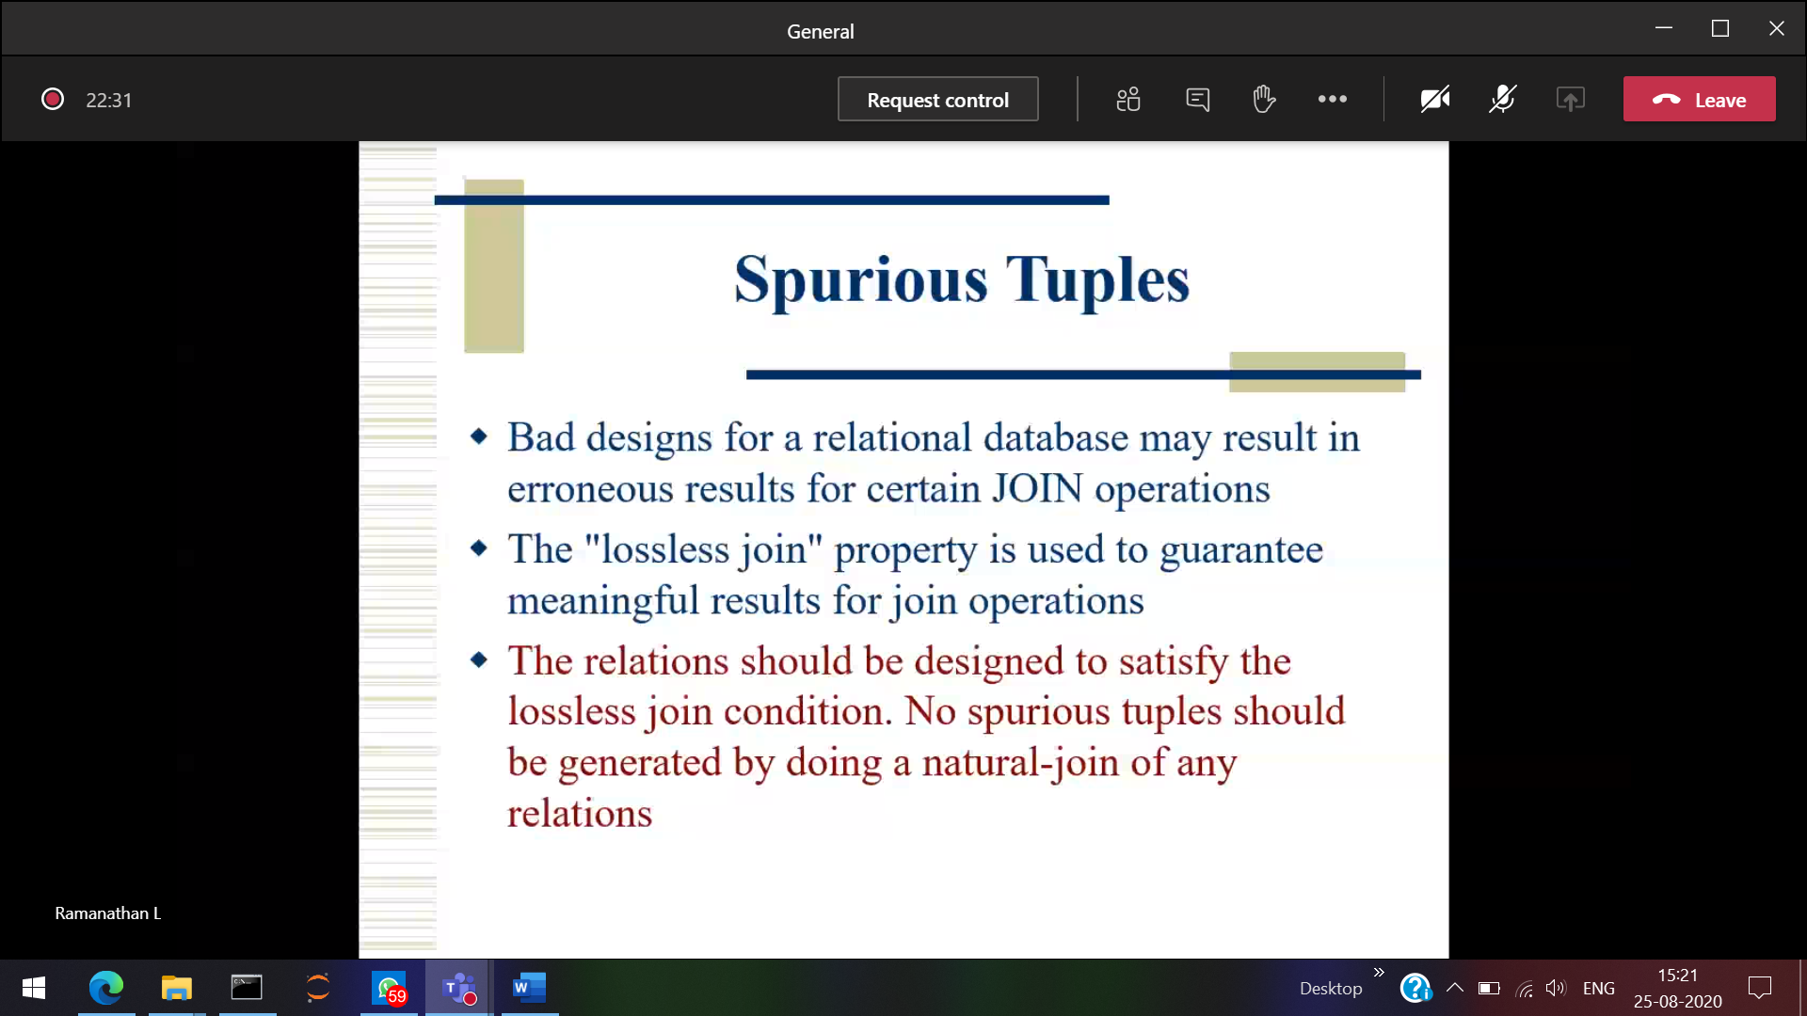

Joining two tables 🡪 More number of duplicate records will be generated due to matrix multiplication.

1 row 1 col (Matrix multiplication)



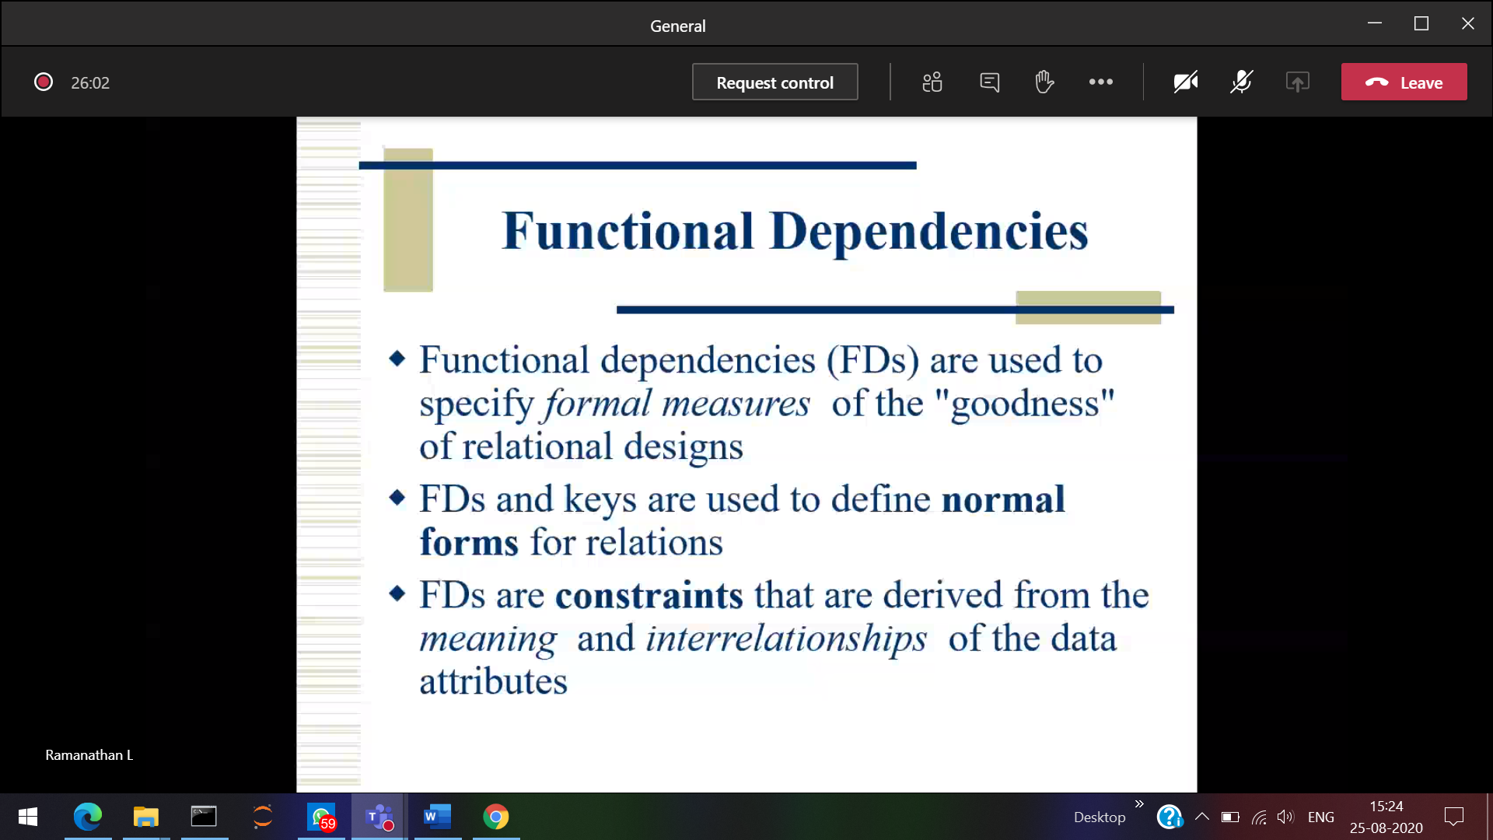

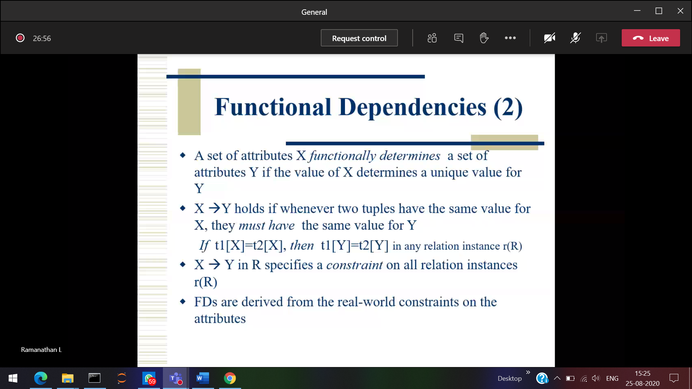



When 1 attribute determines other attribute

Reg no Student name

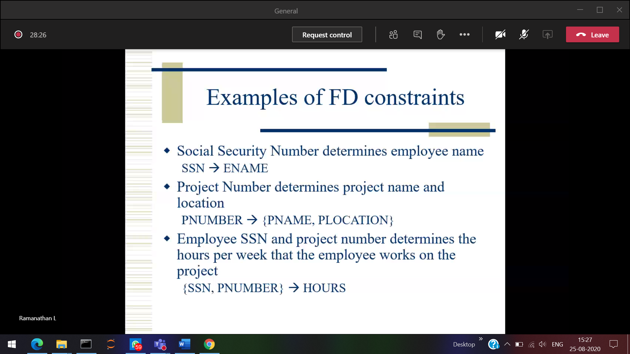

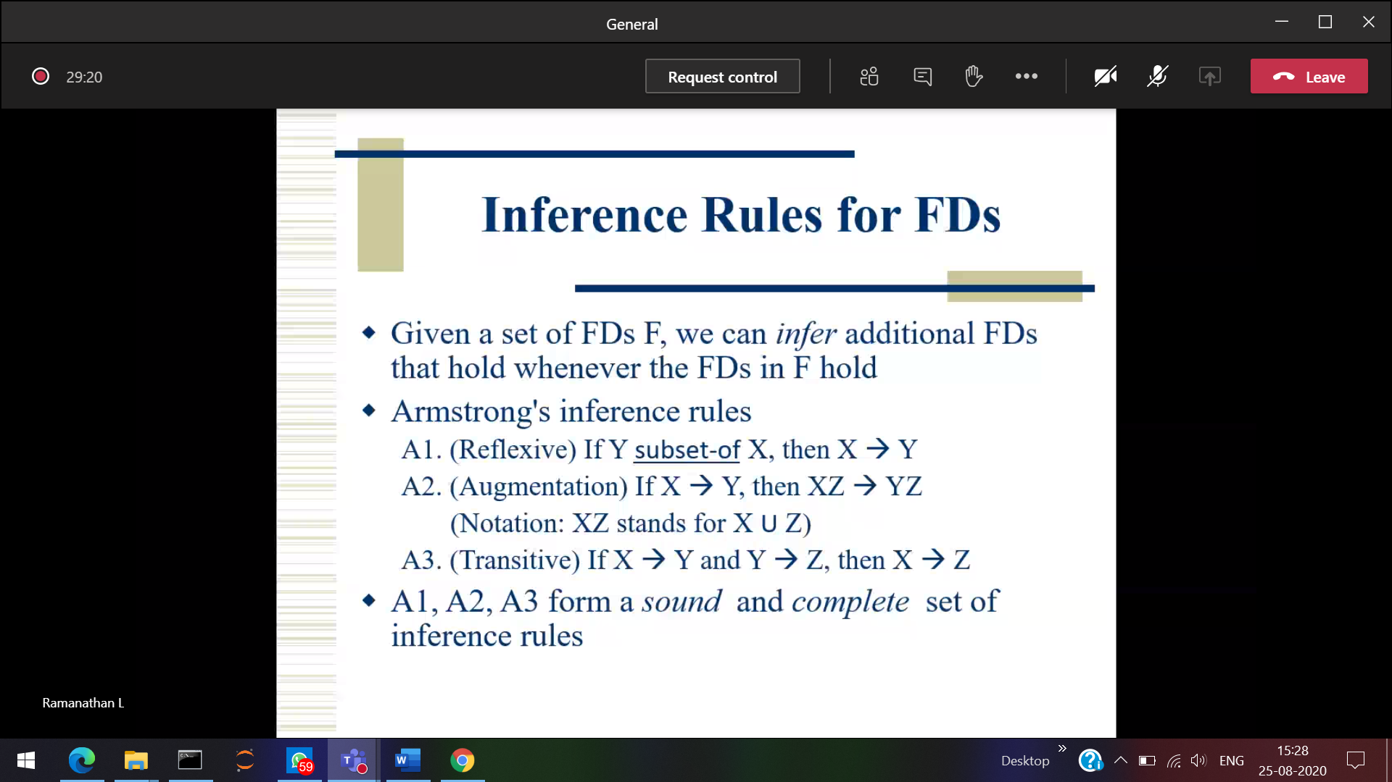

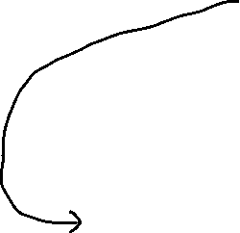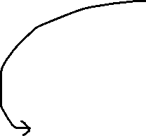

Employ name is a subset of employ id , then employ id will determine the employ

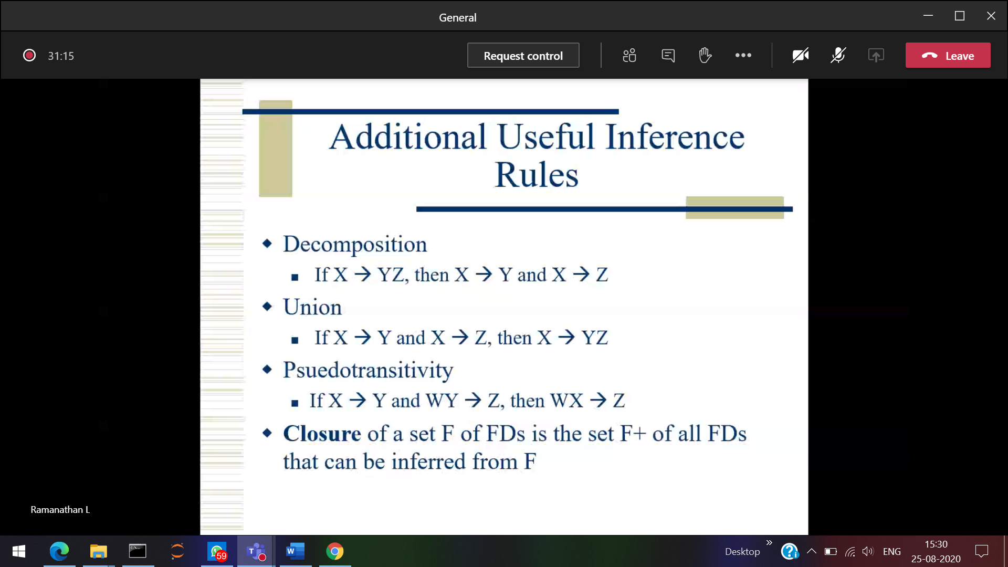

1st Normal form(Cannot be composite/multivalued)

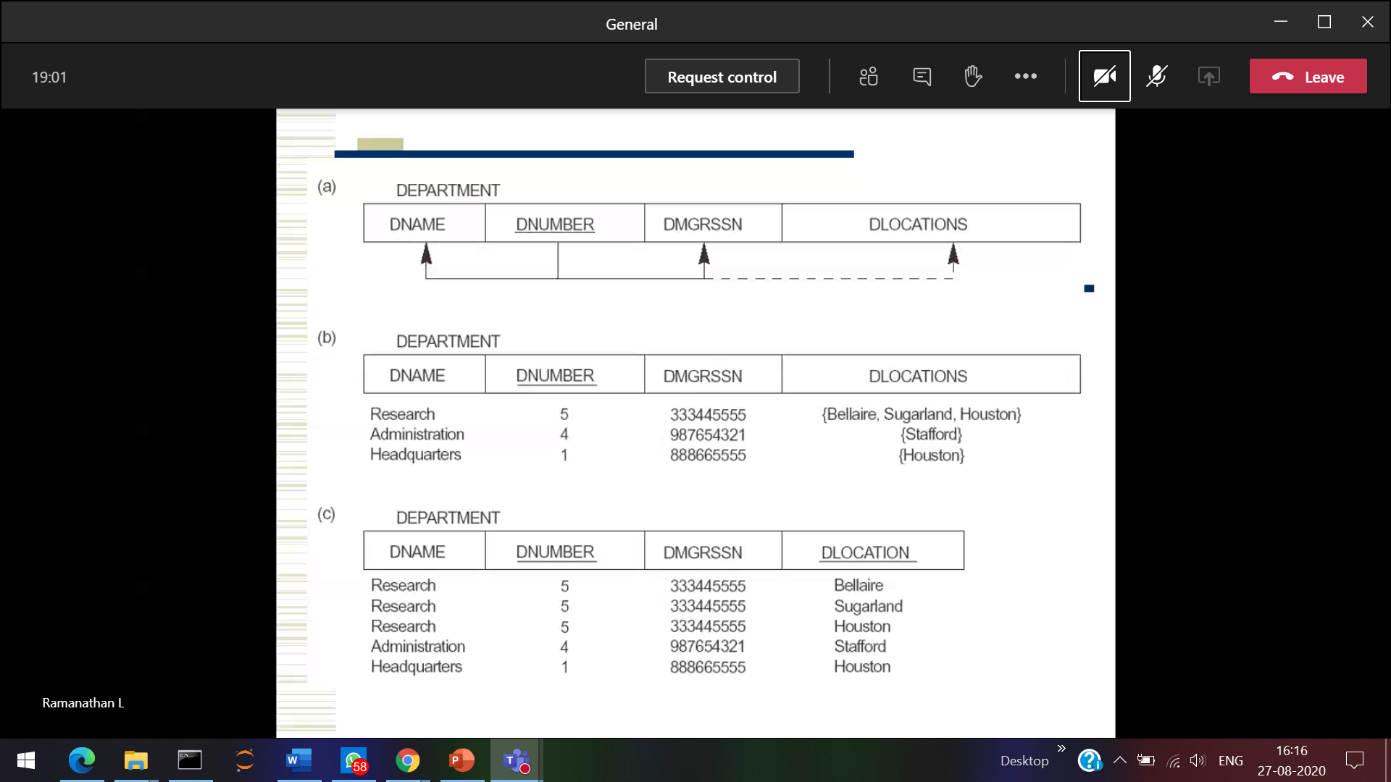



Same info repeated no probs



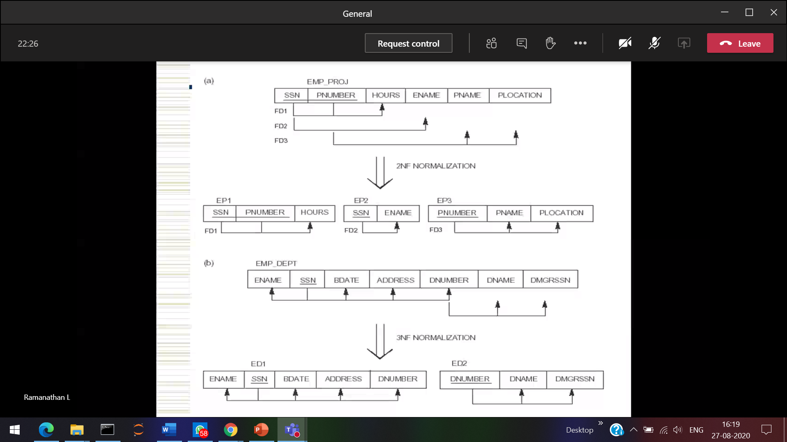



Again Check 1st normal form

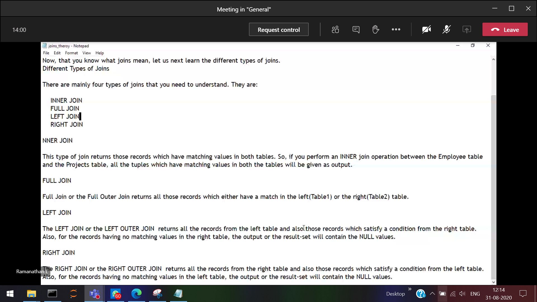

**BCNF**

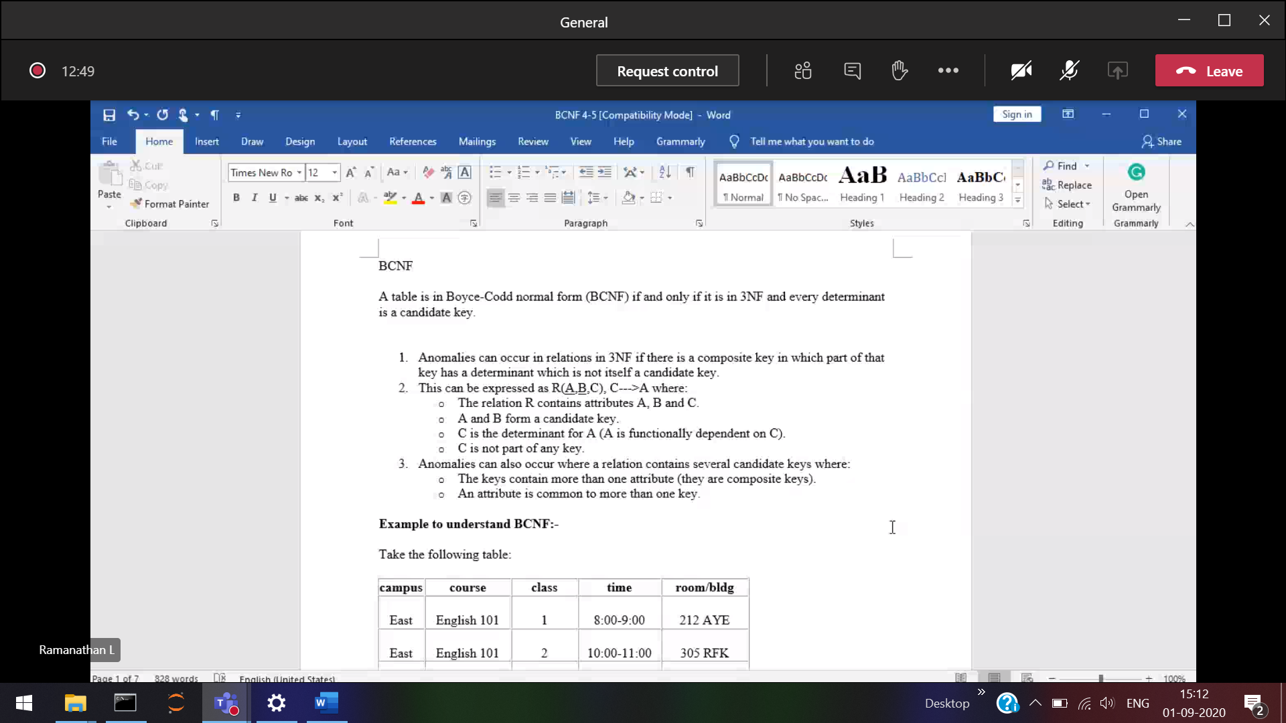

2nd normal form 🡪 should satisfy 1st normal form   
3rd normal form 🡪 should satisfy 1st and 2nd normal form

Every left hand side(determinant) 🡪 candidate key (minimal super key)

room/bldg is the determinant of Campus

4th normal form 🡪 No more than 1 multivalued dependency

No more than 1 skill and 1 hobby

5th normal form Cannot have a loss less decomposition into any number of smaller tables

Split and joining table (while joining the data should not be lossed)

Computing the closure of an attribute????

In F closure whether B🡪G is present???

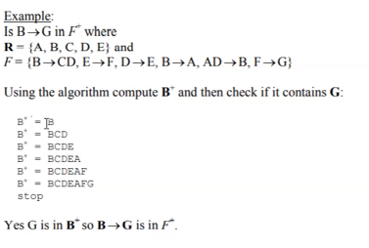

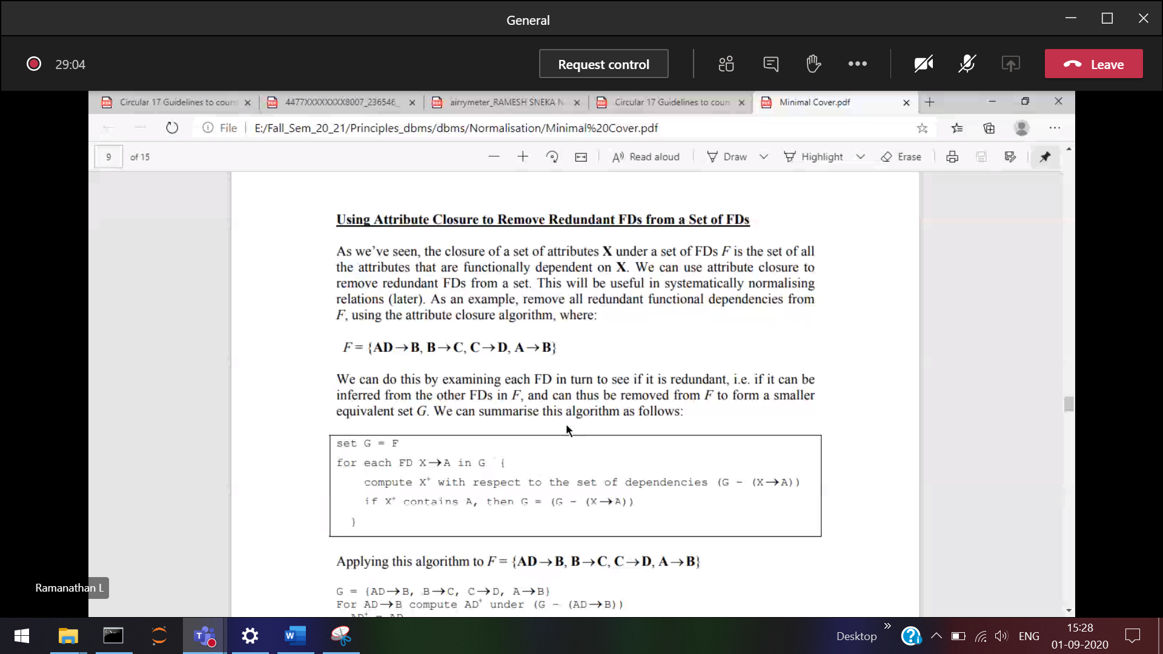

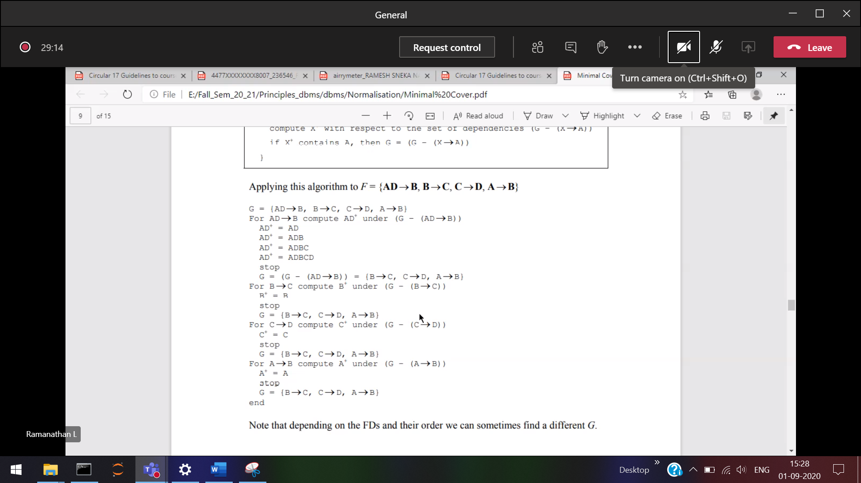  
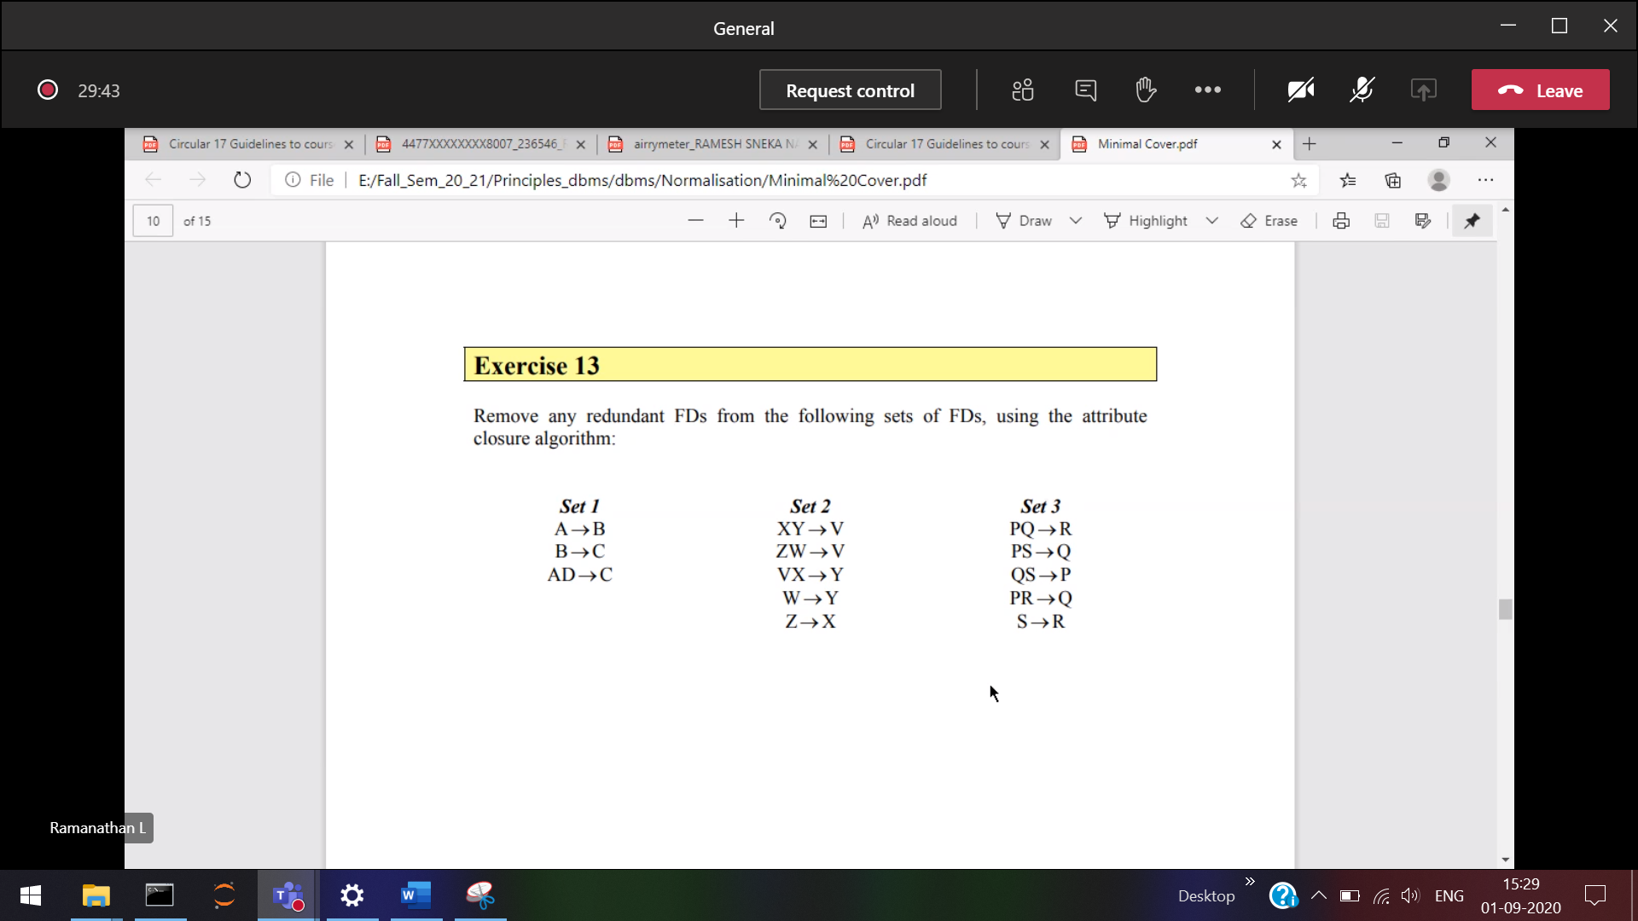

Stop upto finding G

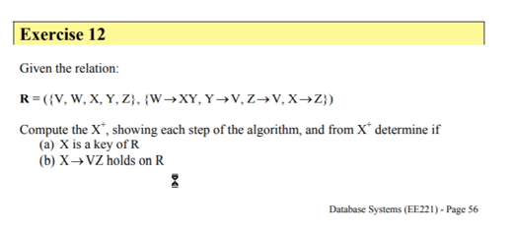

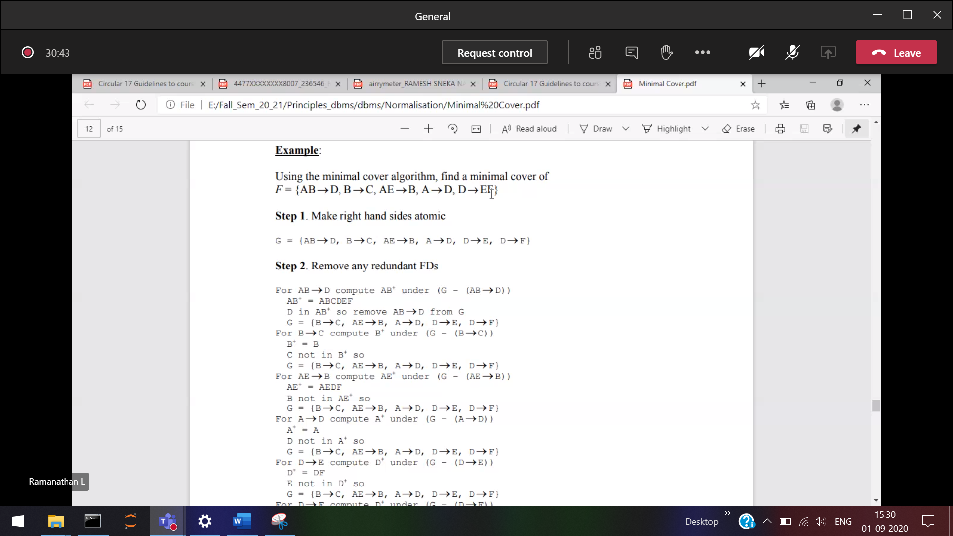



Minimal super key 🡪 candidate key

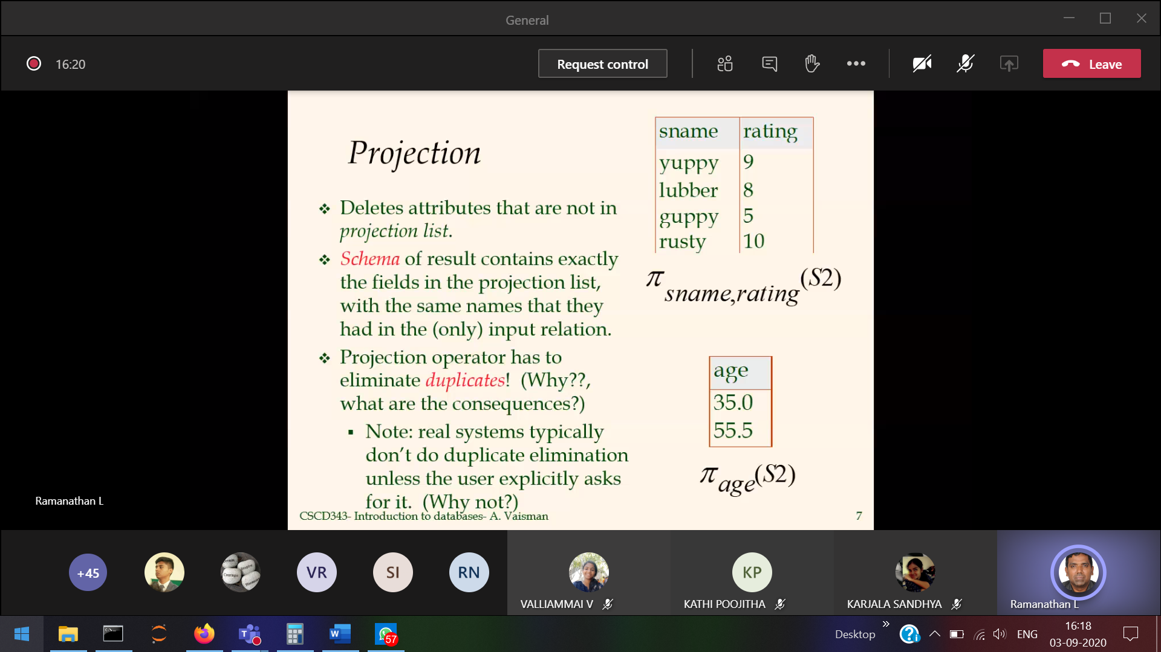

From S2 table retrieving sname, rating attribute

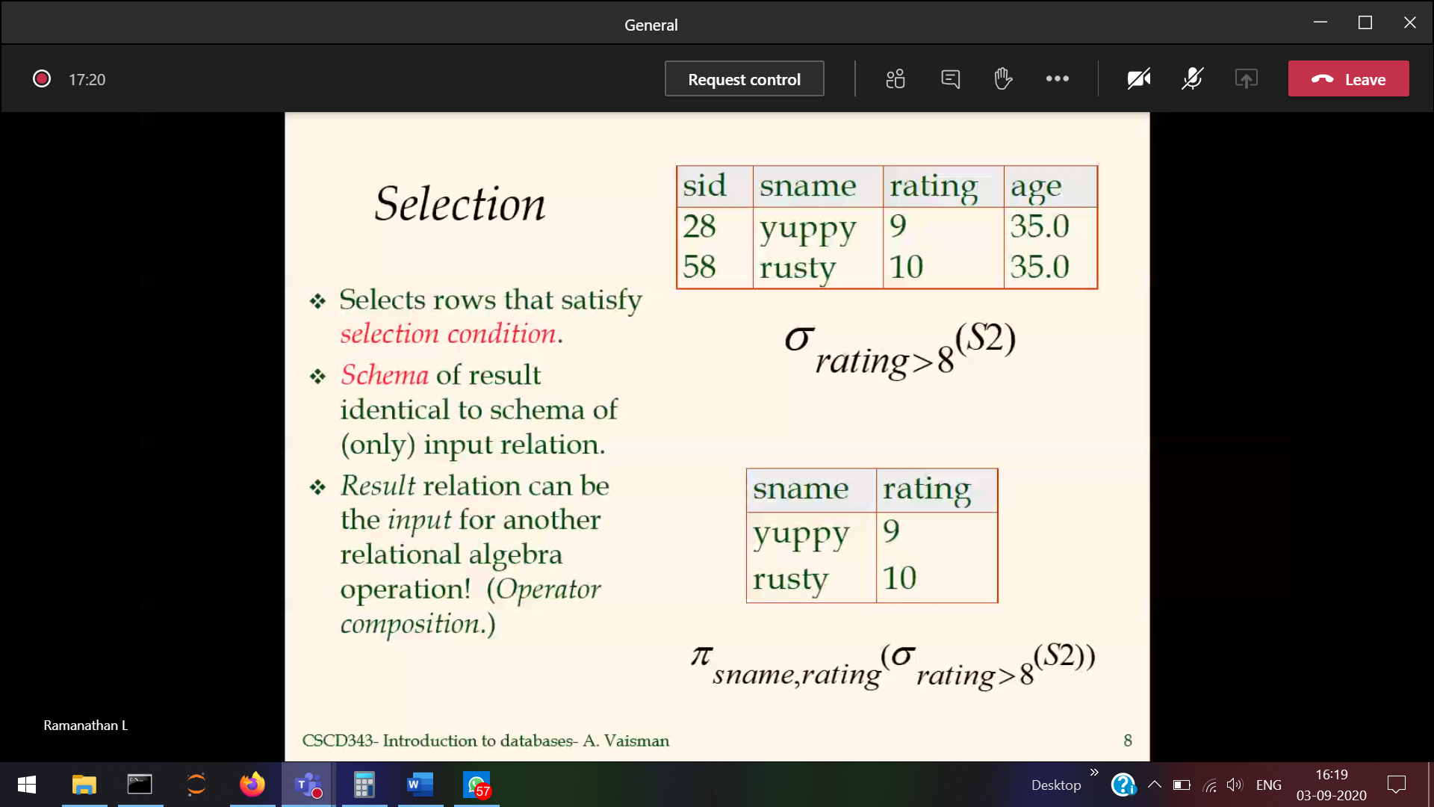

Used to select records from the table

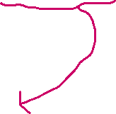

Displays the rows where the rating>8

Inner query 🡪 selecting rows and outer query 🡪 attributes 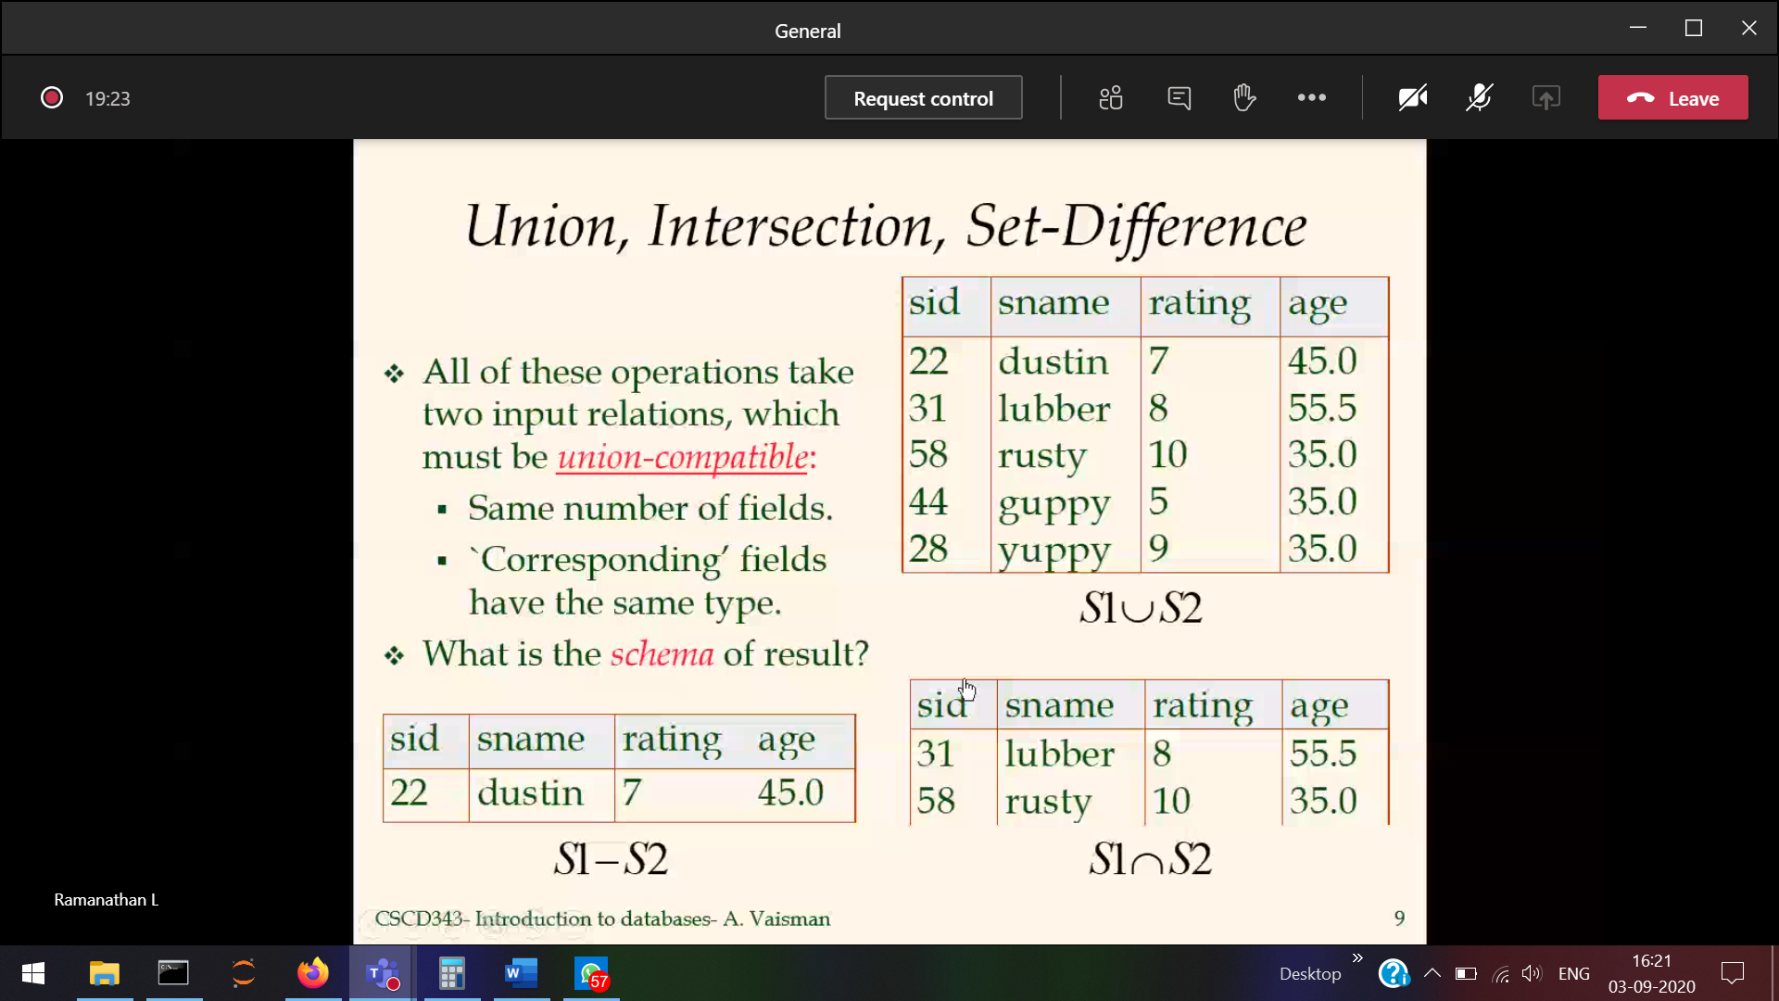

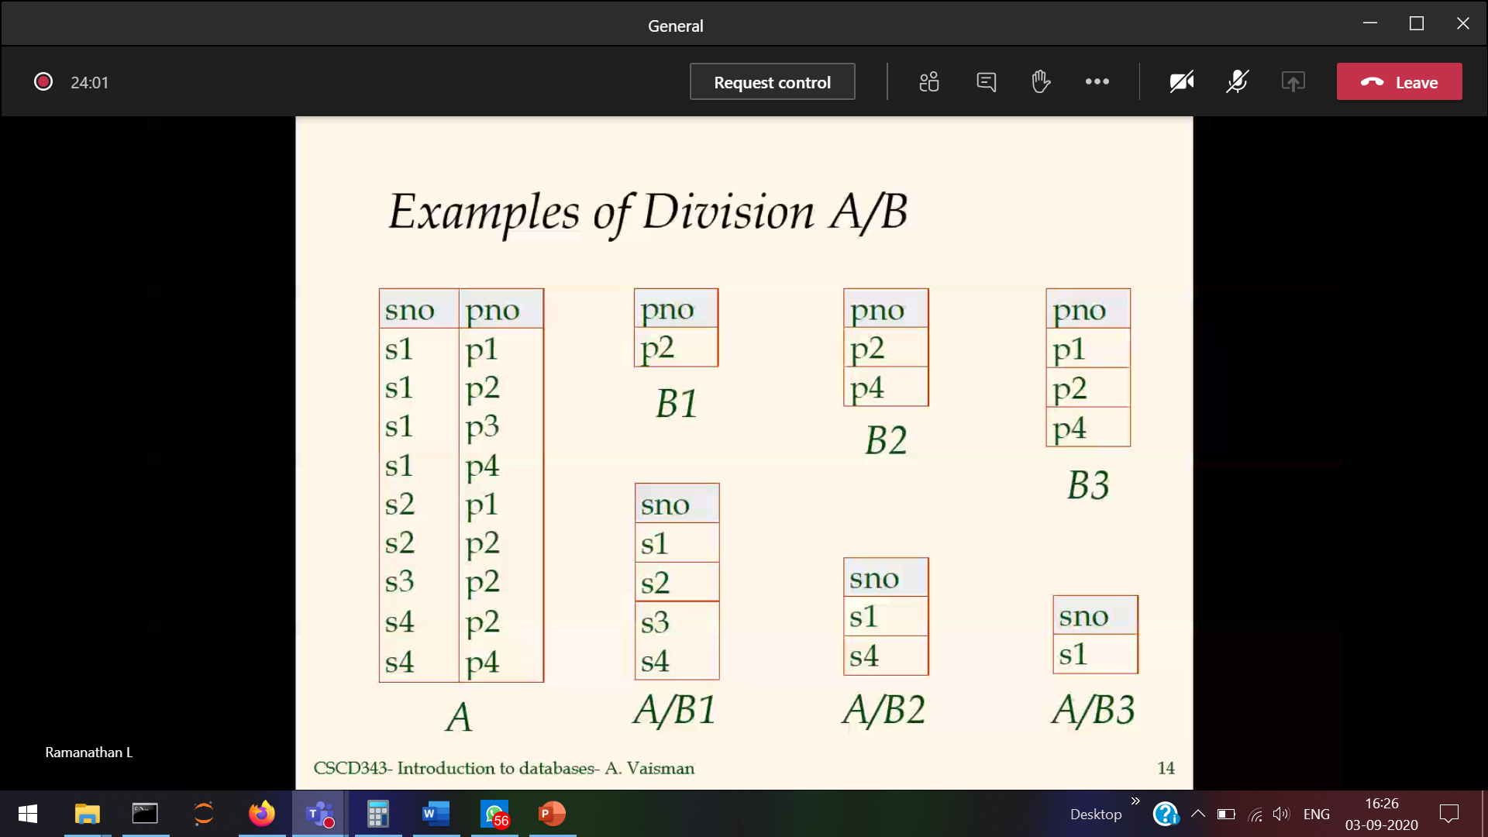

Joining between two table attribute name must be same.  
For joining rename the attribute for some amount of time, then join and change it accordingly

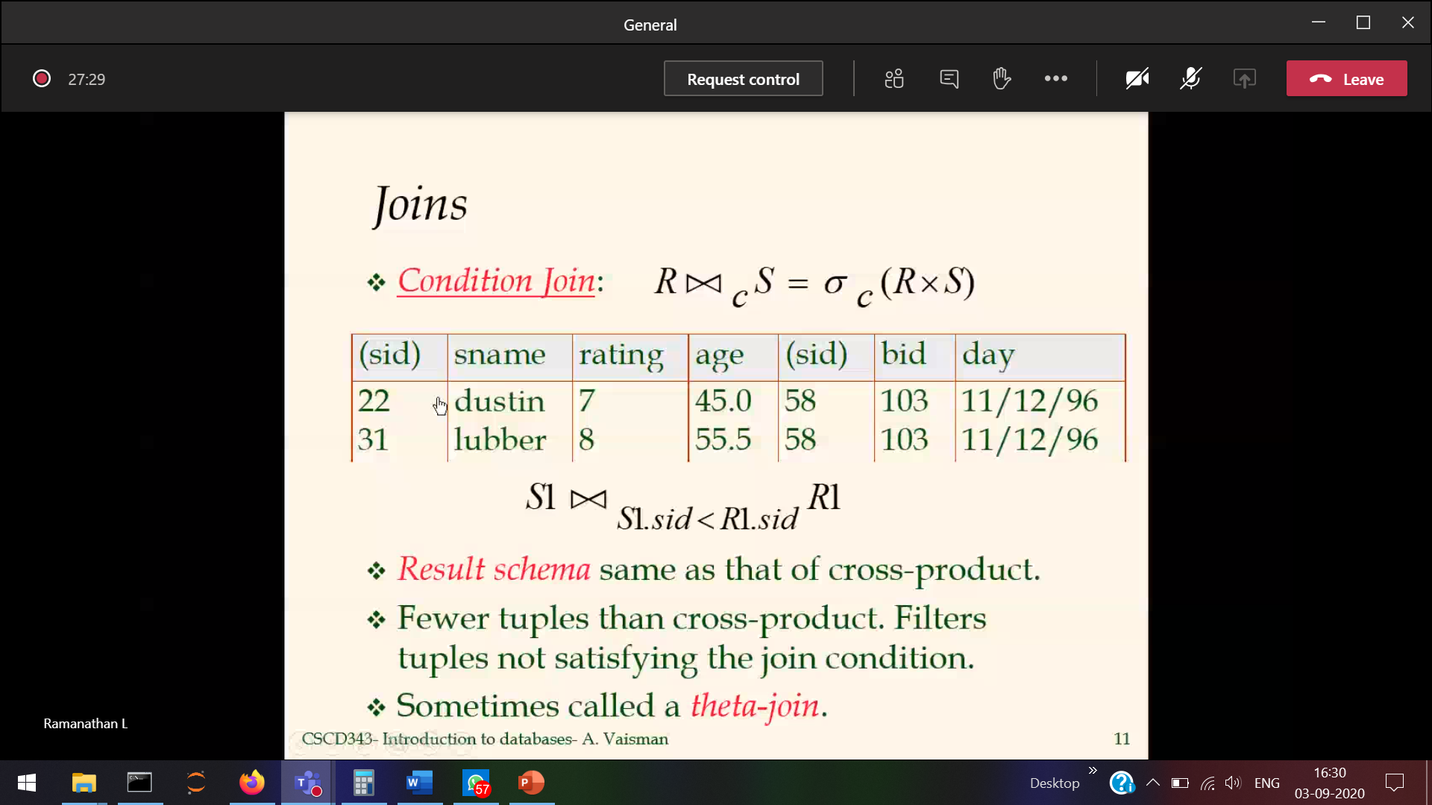

Equivalance of functional dependency

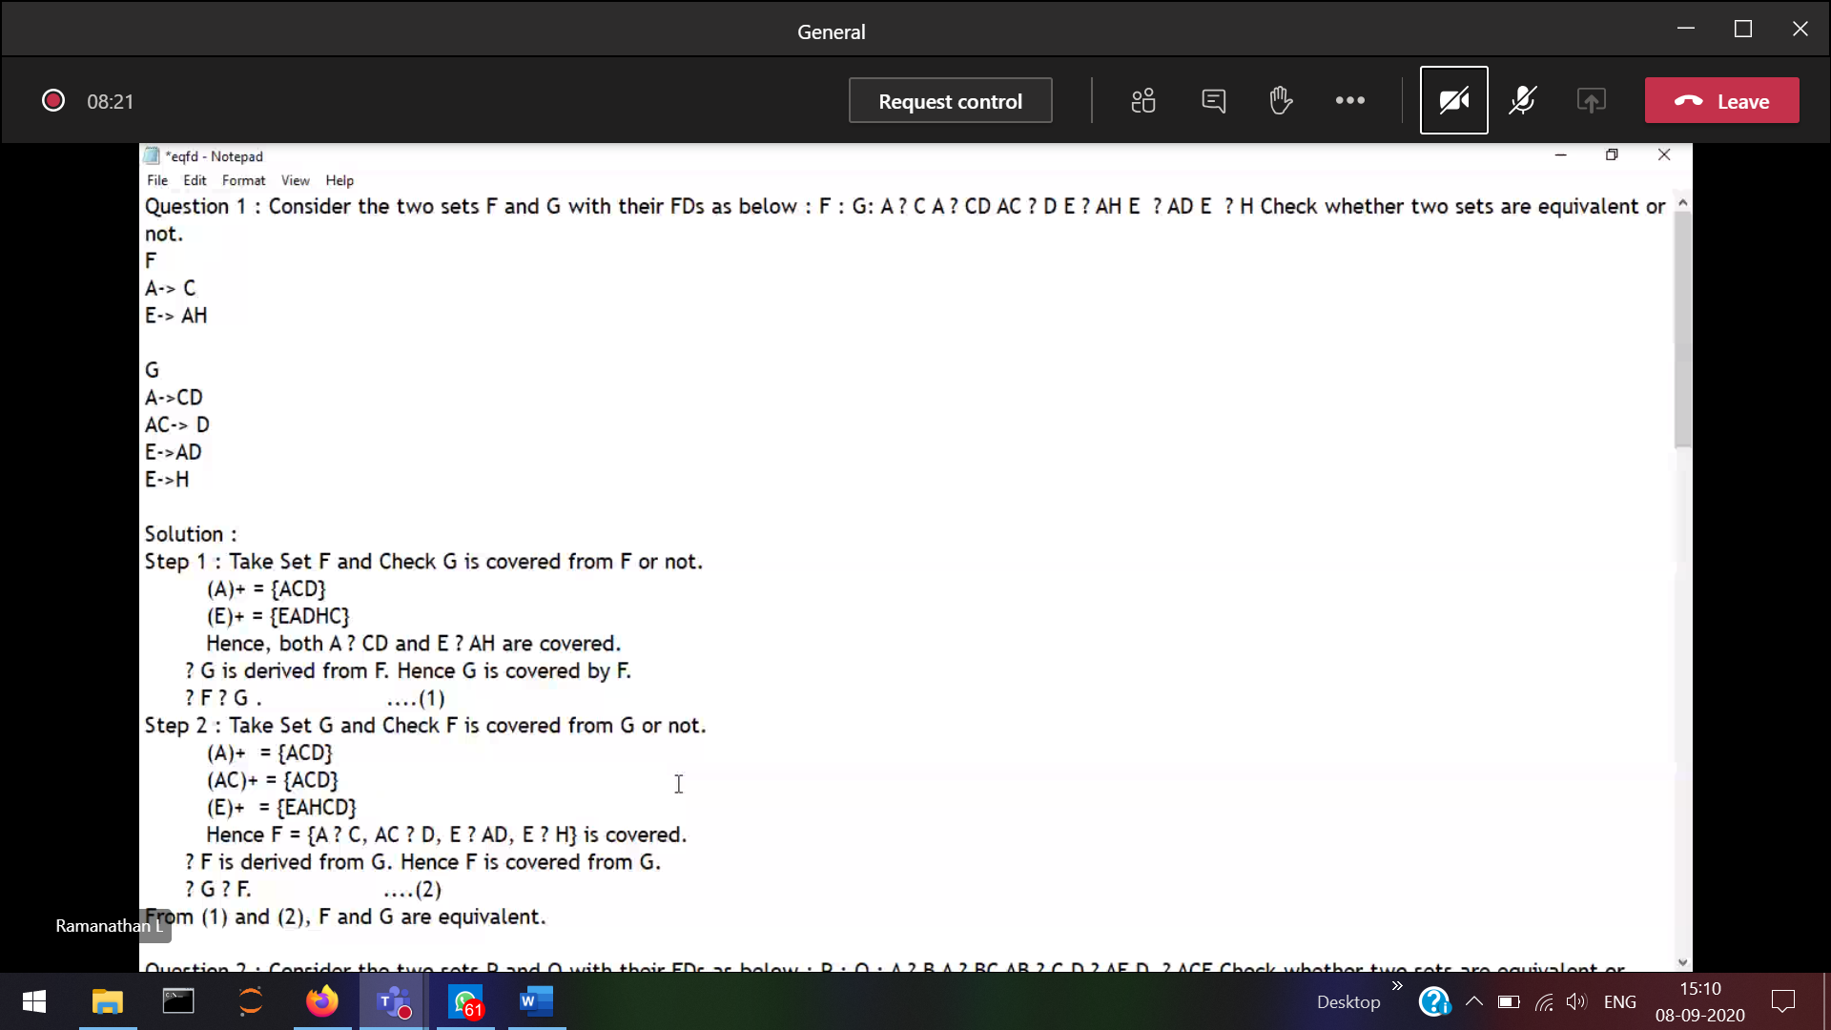

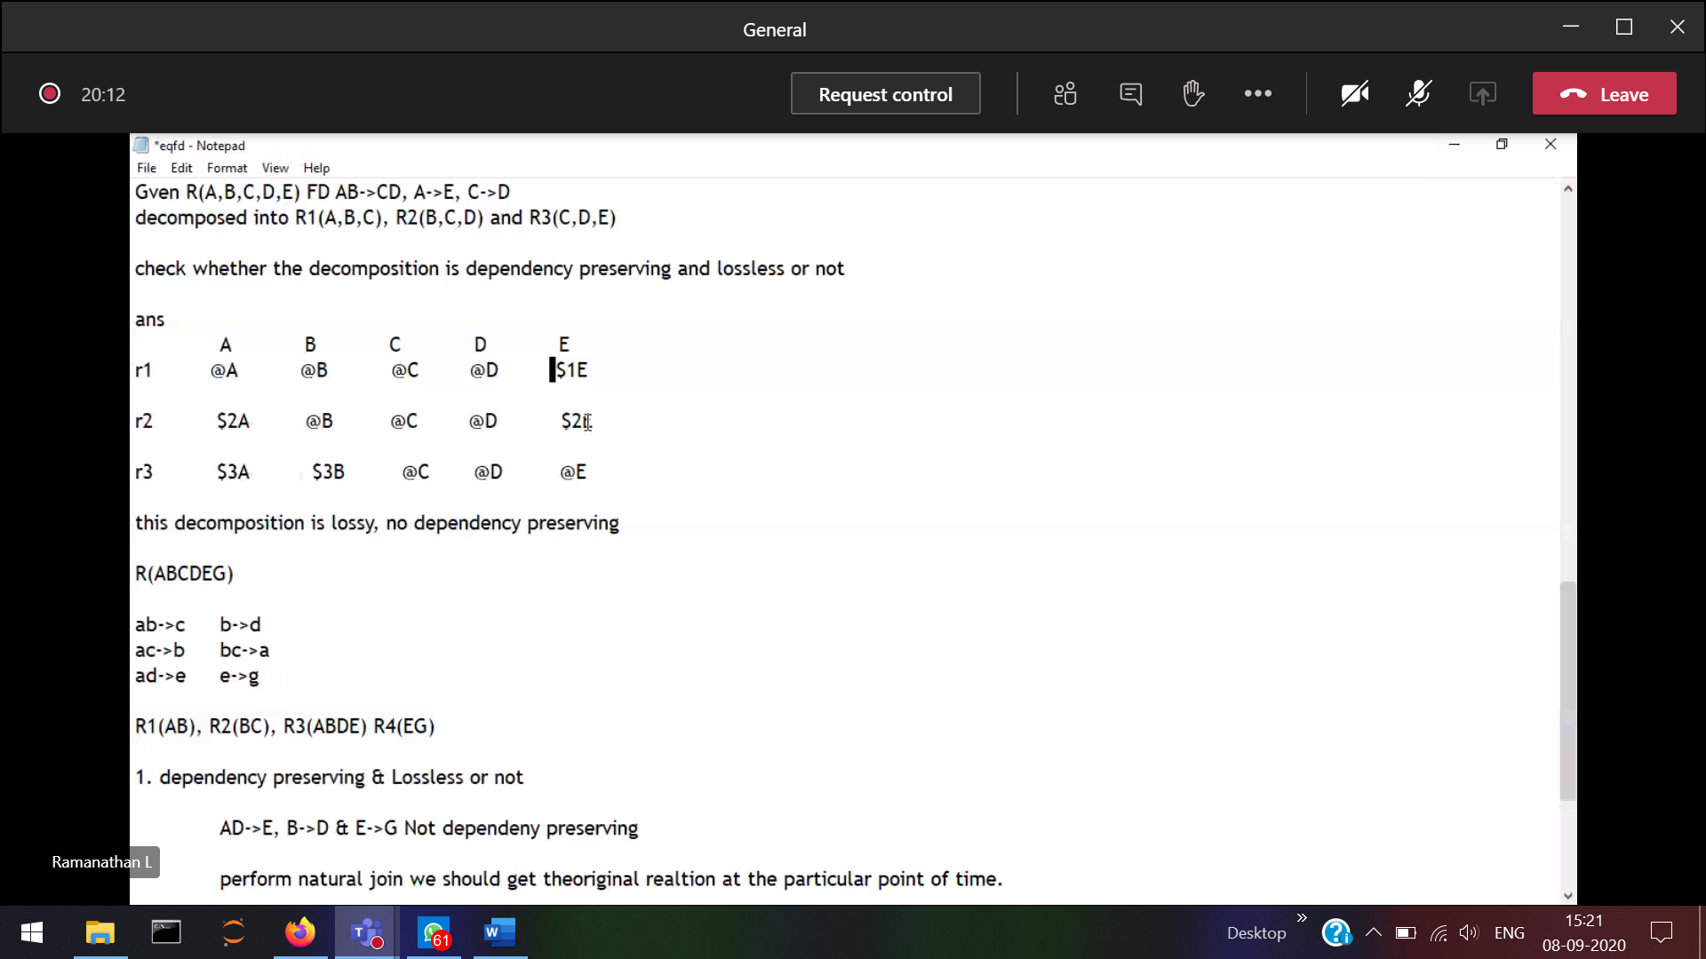

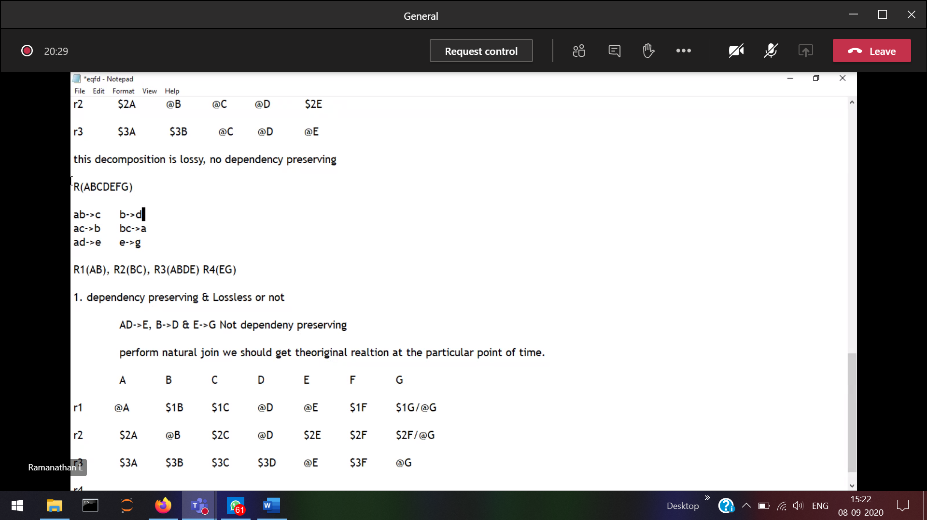

Ab->c remove since(No abc)

Query optimisation 🡪 Shortest path to retrieve the data